**Exercise 1: Control Structures**

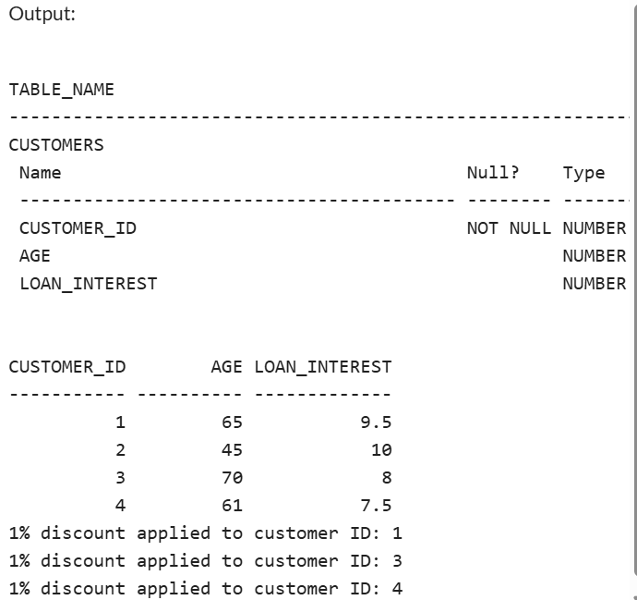

**Exercise 3: Stored Procedures**

